AI Assistant lab assignment 15.4
Name:srija
2303A52412
Batch 44
Task1:
Prompt 1.Develop a basic Flask application for a service management platform.
2.Create a root endpoint /status that returns a JSON response confirming the API is live.
3.Run the server locally.
4.Verify the response using a browser or API testing tool (e.g., curl, Postman)
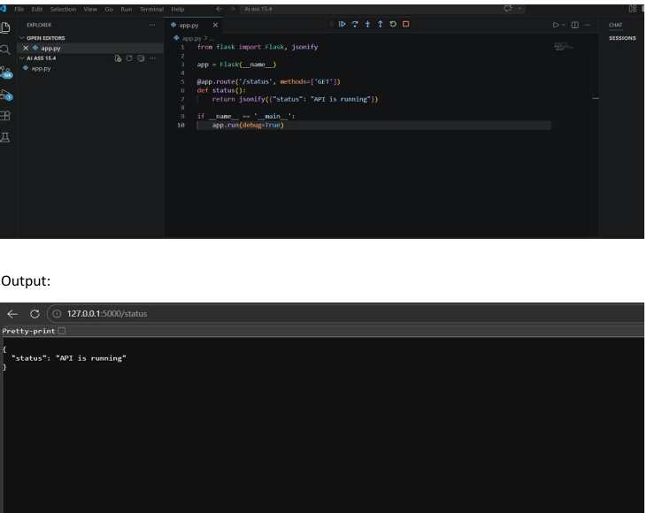
Observation
The Flask server started successfully on http://127.0.0.1:5000/ without any errors.
1. Accessing the endpoint http://127.0.0.1:5000/status returned the expected JSON response: {"status": "API is running"}
2. Theresponse wasverified using both a browser and curl, and the output matched the expected result
Task2:
Prompt: Create a GET endpoint /requests to retrieve all service requests stored in memory.
1. Createa POSTendpoint /requests to add a new request with title and priority.
2. Verify that GET initially returns an empty list.
3. UsePOSTtoaddarequestandconfirm the response.
4. RunGETagaintoensure the addedrequest appears in the list
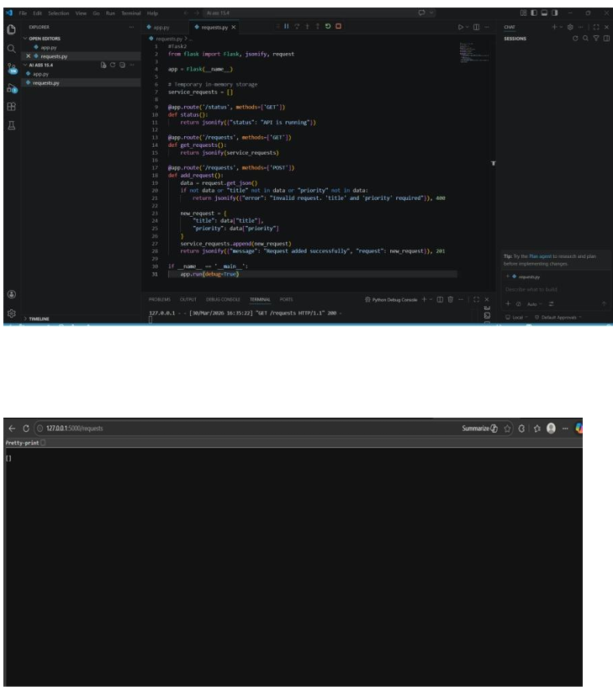
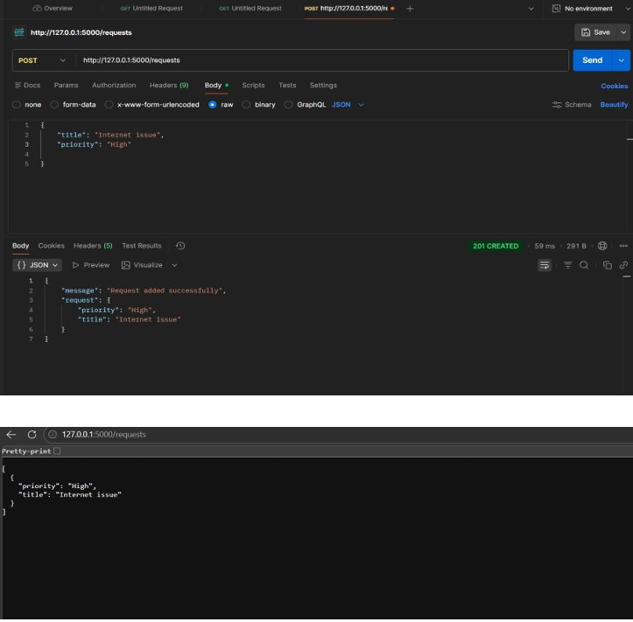
Observation:
1. GET/requests initially returned an empty list [], confirming no requests were stored.
2. POST/requests with {"title": "Internet issue", "priority": "High"} returned a success message along with the added request object.
3. Subsequent GET/requests returned the list containing the newly added request, verifying that the POST and GET endpoints are working correctly.
Task3: Prompt: Create a PUT endpoint /requests/ to update a service request by its index.
1. Ensure the request body contains both title and priority.
2. Return the updated request object along with a success message.
3. Handle invalid indexes gracefully by returning a clear error message with HTTP 404.
4. Verify that subsequent GET requests reflect the updated data.
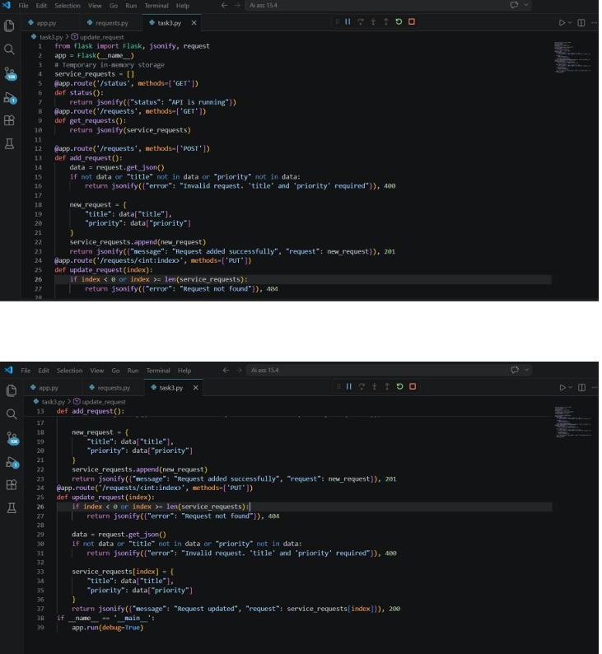
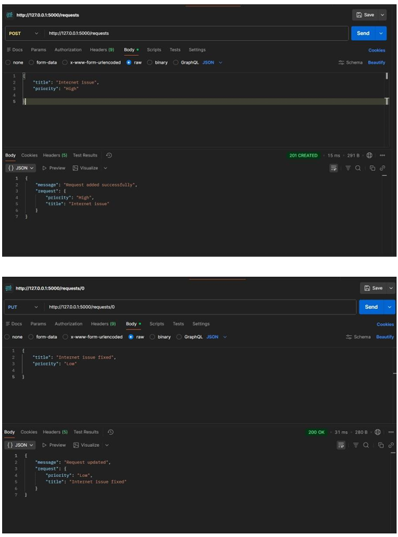
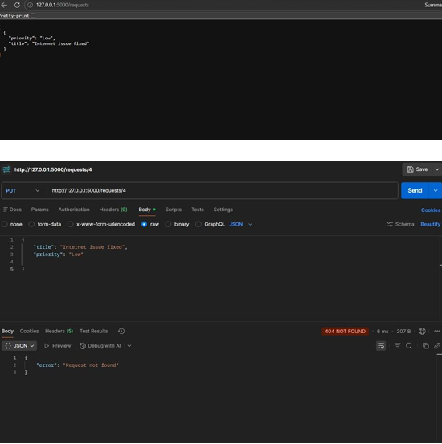
Observation:
1. AvalidPUT/requests/0 successfully updated the request’s priority and returned the modified object with the message: {"message": "Request updated", "request": {...}}
2. Aninvalid PUT /requests/5 returned a clear error response: {"error": "Request not found"}
3. withHTTP 404,confirming proper error handling.
4. Theupdatedrequestwas correctly reflected in subsequent GET /requests calls, proving that the PUT endpoint works as intended and integrates seamlessly with the existing GET and POST endpoints
Task4: Prompt: Create a DELETE endpoint /requests/ to remove a service request by its index.
1. Ensure the deleted request details are returned in the response for confirmation.
2. Handle invalid indexes gracefully by returning a clear error message with HTTP 404.
3. Verify that subsequent GET requests confirm the removal of the deleted request.
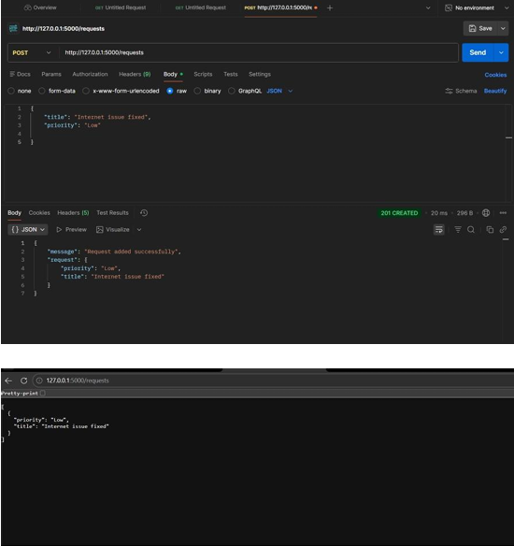
Observation
1. Avalid DELETE /requests/0 successfully removed the request and returned its details with a confirmation message: {"message": "Request deleted", "request": {...}}
2. Aninvalid DELETE /requests/5 returned a clear error message with HTTP 404, confirming safe error handling without crashing the server.
3. Subsequent GET/requests calls showed the list without the deleted request, proving that the DELETE endpoint works correctly and integrates seamlessly with the existing CRUD operations.
Task5:
Prompt Add meaningful docstrings to all endpoints describing their purpose, HTTP method, inputs, and outputs.
1. Insert inline comments in the code to make logic and flow easy to follow.
2. Clearly describe request methods, expected JSON body, and sample responses for each endpoint. 3. Optionally integrate Swagger/Flask-RESTX to automatically generate interactive API documentation showing:
• Endpointpaths
• HTTPmethods
• Samplerequest/response formats
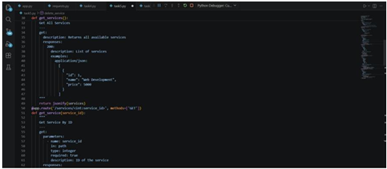
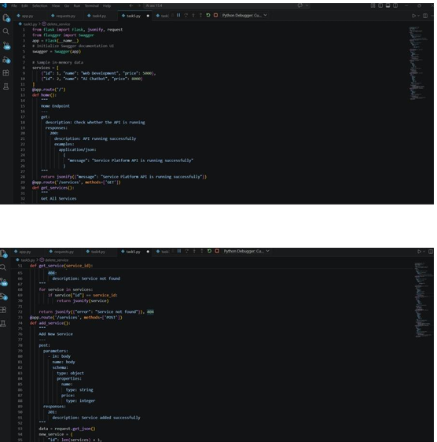
Observation:
Each endpoint now has well-structured docstrings that explain its purpose, request method, required inputs, and possible responses, making the API self-explanatory.
1. Inline comments improve readability, allowing another developer to quickly understand the logic without reading the full code.
2. TheAPIisready for optional integration with Swagger/Flask-RESTX, which would provide a browser-based documentation UI displaying endpoints, methods, and sample request/response formats for easier collaboration
